24 Video Lecture – Reading from APIs

**APIs defined**

1. API = Application Programming Interfaces
2. most websites offer them for gathering data
3. use httr package for sites with such APIs

**Creating an Application**

1. step one, create an account with the site’s api such as twitter
2. step 2, after creating an account with the site’s api, create an ap
3. step 3, gather all the keys, tokens and codes for the app, save for later use in R

**Accessing the API using R**

1. library(httr)

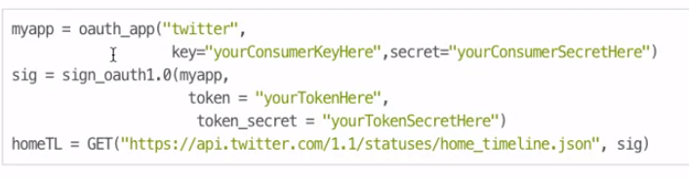

**Convert the JSON object from the twitter API to look useful, since JSON is terrible**

library(rJSONio)

library(jsonlite)

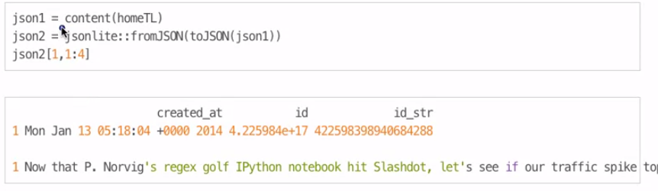

**Which URL to use**

1. go to the site’s developer pages, look for the GET requests
2. it will have something called the Resource URL that gets plugged into R
3. Read the parameters associated with the Resource URL, it will be useful for better understanding the results

check out the httr demos on its package page